Compression garments are pieces of clothing that fit tight around the skin. In medical contexts, compression garments provide support for people who have to stand for long periods or have poor circulation. These come in varying degrees of compression as follows.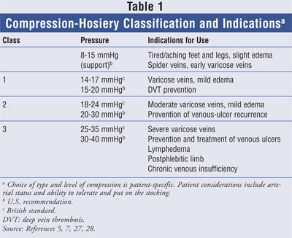
The current body of research identifies that compression garments may improve joint awareness, local blood flow, waste product removal, improve running economy, reduce swelling, reduce muscle oscillations, and decrease post-exercise muscle soreness
- facial mask for head and neck surgery
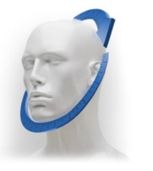
Department: Head and neck surgery department, oncology, oral and maxillofacial surgery.

Use
Facial Mask is specifically targeted to the neck and chin for a lifted, firmer and tighter look after the surgery and also provide a support and to reduce the edema too. It is used to lift and tighten the appearance of loose, sagging or drooping skin in problem areas around the chin and jawline.

- Sleeves for hand.
How to measure.
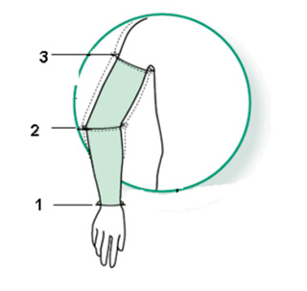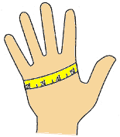

Product
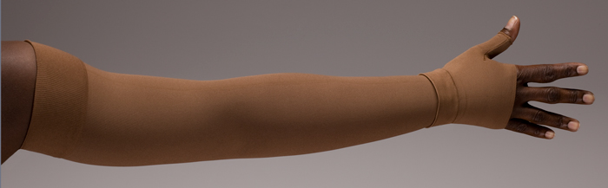
Decription.
Compression sleeves and garments are designed to apply pressure to the arm, hand, or trunk to keep lymph moving and reduce edema skin Sagging.
Departments used in
Plastic surgery, Oncology, General Surgery, diabetic department.

- Liposuction Garments
Product

P-100, p-122 Body Suit
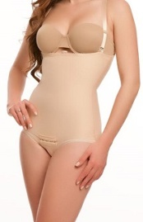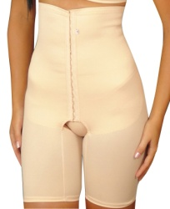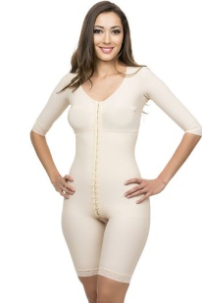

Used after
Abdominoplasty surgery
Liposuction surgery
Hernia surgery
Bariatric surgery
Caesarean Surgery

- Description- To reduce swelling or bruising. Compression garments help reduce swelling (edema) and aid in pushing fluids into the lymph system for removal from your body. The compression from the garment will help hold skin firmly against the body, aiding in proper skin retraction and general body contouring. support the abdomen, maintain abdominal pressure.
After surgery, an abdominal garment is thought to:
- support your surgical incision
- relieve pain
- get you moving more
- reduce swelling

Department
Plastic surgery, general surgery, gynaecology department, bariatric surgery laparoscopic surgery, gastro surgery

- Males vest for gynecomastia
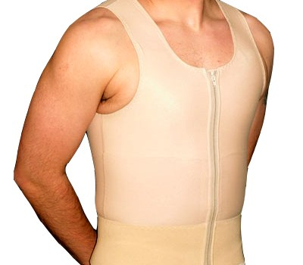P-114

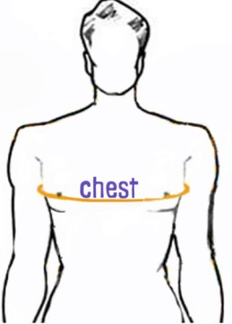
Department- Plastic surgery General; surgery.
Use- Compression garments are most important in the first 48 hours after surgery. They help reduce the risks of bleeding and bruising. it decreases pain, prevents seromas (fluid collections), stimulates blood flow to the area, allows for skin contraction, and improves shape. Especially for those moderate to severe cases where there is an excess in skin, continuous wearing of the vest for longer than 3 weeks really is essential to obtaining the best contour in the long run.

5.Stockings Below knee and above knee.

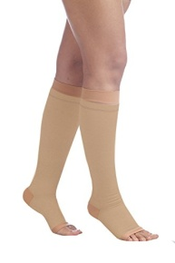p-101 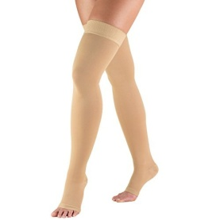p-102
Description- Compression stockings:
- Help improve blood flow.
- Reduce lymphedema
- Help keep blood from pooling in the legs.
- Help relieve symptoms caused by varicose veins, skin ulcers, and deep vein thrombosis.
- Help prevent problems caused by things like skin ulcers.
- Will help the most if you wear them every day while you're awake, especially while you're on your feet.
Departments used in- General surgery, Plastic Surgery, Oncology, cardiology

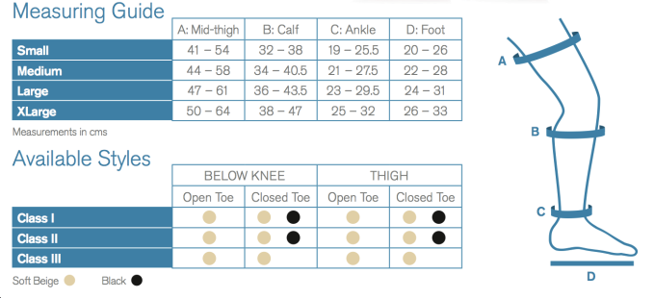 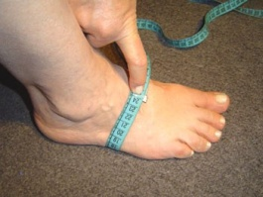 Foot measurement

6.Band for keloid.
It is purely custom made depending on the area to be used and contact for more details.

7. Silicone Gel Sheets - silicone gel sheets helps to flatten and fade thick, red scars. These are technically called "hypertrophic scars". Use of silicone gel sheeting (recommended min 90-day treatment duration, on at night, off during the day) can improve the over-all appearance of surgical scars

Size

5*5

10*10

10*20

20*20

40*40

Results after sheet use

Department used- plastic surgery , general surgery

Used in scar reduction treatment, for keloids treatment, for skin grafting etc

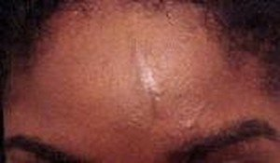

8.Silicon nostril retainer.
Department Plastic & Reconstructive Surgery
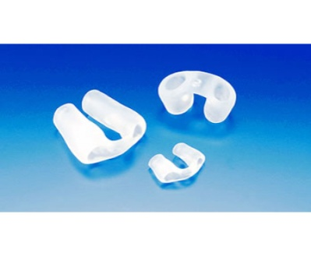
Used in Rhinoplasty commonly known as a nose job, is a plastic surgery procedure for correcting and reconstructing the form, restoring the functions, and aesthetically enhancing the nose by resolving nasal trauma (blunt, penetrating, blast), congenital defect, respiratory impediment, or a failed primary rhinoplasty.

Purely custom made depending the age group of the patient. For more info please contact.

9. Abdominal Binders
. An abdominal binder may be used to speed-up the recovery process after abdominal surgery. Your doctor may recommend that you wear an abdominal binder after:
- a caesarean section
- bariatric surgery
- an exploratory laparotomy
- a hysterectomy
- a tummy tuck
- spinal surgery.
Use
- support the abdomen, maintain abdominal pressure.
After surgery, an abdominal garment is thought to:
- support your surgical incision
- relieve pain
- get you moving more
- reduce swelling

departments used-
plastic suregery Gynaecology department , bartiatric surgery, laproscopic surgery, gastero surgey, general surgery,.

Measurement


10. Compression Bras
Used in Breast augmention and reduction or mastectomy .
The use of a post-surgical bra following breast surgery (augmentation, lift, reduction) is for both support and compression. Providing good support is more important than excessive compression. The ‘support’ will decrease post-operative pain and discomfort, reduce early stress on the skin closures, and help reduce dependent swelling within the breast. The ‘compression’ will help reduce swelling and enhance its resolution.

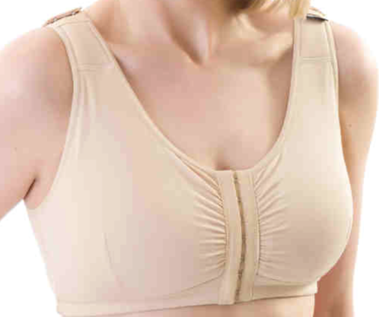 B1 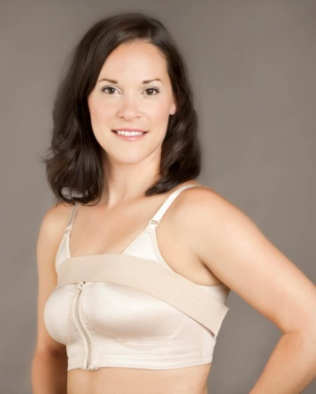B2

Departments- Plastic surgery, oncology surgery department.

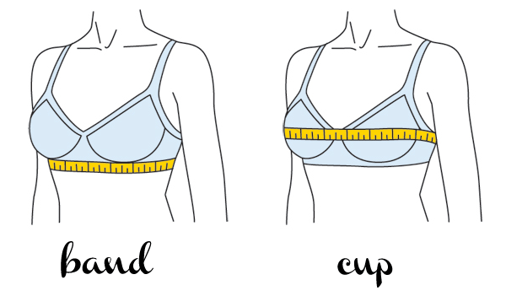Measurement ways

